MainSail Charters & Research, LLC
BIG BOATS and BASIC SAILING

Revised 6-20-15

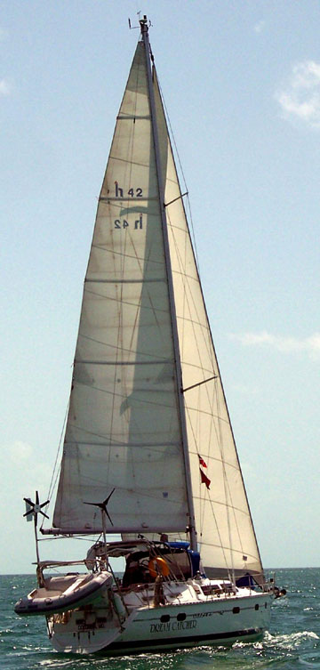
COURSE OBJECTIVES

The objective of this course is to update known sailing basics and to acquaint the student with additional basic sailing techniques affiliated with the operation of a larger boat. At the end of the course the student should be capable of operating an auxiliary powered sailboat between 30 and 45 feet safely in fair weather and moderate winds on local and inland waters both as skipper and crew during daylight hours. The student may expect to encounter moderate sea and wind conditions during this course.

Schedule:
This is a two day course 8 hours per day for a total of 16 hours which may be taken over the weekend or during the week.

Student Instructor Ratio
A maximum of six persons will attend the course.

COURSE CURRICULUM
MAINSAIL CHARTERS & RESEARCH, LLC
BASIC SAILING-Two day course:

Tuition:
$475.00 per person. If two or more individuals sign-up together, there is a $50.00 per person reduction in price.

This is a two day course which may be taken over the weekend or during the week. Students may elect to stay overnight on Dream Catcher or appear daily at the dock.

The course will go from 1000 to 1600 hours each day. The course duration may be extended based on weather conditions at the discretion of the Captain and unanimous consent of the students.

Overnight Stay:
If the student elects to stay overnight, costs for an overnight stay is $50.00 per person. Evening meals are not furnished as part of the course. There are a number of restaurants in the vicinity. During the overnight stay, Dream Catcher will be berthed at Holiday Hill Marina, on White Marsh Creek off the Rhode River, Mayo, Maryland.

Cancellation/Reschedule Policy
In the event of in-climate weather, determined by the instructor, the course may be re-scheduled either as a full re-schedule or by individual days. The instructor may also halt the course during the term of instruction should in-climate weather arise. Rescheduling of classes will be negotiated.

Cancellation may occur in the event of violent / severe weather or issuance of small craft warnings by the National Weather Service.

All consideration will be given to the student to notify of a cancellation prior to the class schedule. Students are advised to watch the weather and call an hour and one half before scheduled beginning time if it appears in climate weather is approaching. Students will be notified by 0730 hours on the day of the class if a cancellation is occurring or immanent. The instructor reserves the right to cancel the course at any time, winds exceed 25 knots, to reschedule the course based on the time of cancellation. All efforts shall be made to continue the course through to completion.

Student Instructor Ratio
A maximum of six persons will attend the course.

Payment: At the time you sign up for the course and have been scheduled, a 50% deposit is due at the time. The remainder of your tuition is required within 5 business days prior to the start of the course. Check, cash or credit card check will be accepted for both the deposit, the remainder of the course fee and/or the full tuition. In you are unable to attend the course, a full refund will be given provided that you notify us 7 days prior to the scheduled start of your training. In the event of in-climate weather and you elect to not further pursue the course by rescheduling, a 75% refund will be given. MainSail Charters & Research, LLC will gladly work with the student to re-schedule at his or her convenience. We want you to learn to sail.

What to bring.
Except for the absolute worst of conditions basically defined as NOAA issued “Small Craft Warning” or National Weather Service issued Severe Weather Warnings, the student can expect to sail whether it is raining or not. Consequently, rain gear should be considered essential. As it is hot and sunny at times, sunscreen and a hat are essential. Gloves should be considered. Dress appropriately. In the summer, light colored loose fitting clothing is comfortable and should be considered. Tennis shoes, boat shoes or similar foot wear is acceptable. As the deck may be wet and slippery, a good sole on the shoe is advisable. Do not wear slick sole shoes if something else is available. Flip flops and crocs are also acceptable.

DO NOT WEAR BLACK SOLE SHOES and if you bring them, they will not be allowed to be worn while on the boat.

Food and Beverages:
The student should bring his or her own lunch for the first day. Water and soft drinks and ice will be provided by the Instructor. NO Alcoholic beverages will be allowed during the duration of the course. For those who choose to stay over, while the boat is at anchor, moderate alcohol consumption, at/to the discretion of the instructor, will be allowed. If during this time, the Captain determines that alcoholic consumption has exceeded safe margins, the consumers will be asked to stop. Failure on the part of the consumer in question, to stop will result in an expulsion from the course with no refund of fees.

Objective Description:
The objective of the course is to provide a detailed working knowledge of:
- basic sailing,
- parts of a sailboat and
- general boating safety and general rules of the road (maneuvering on the water).

The objectives for the student should be:
to have a demonstrated ability to skipper a sloop-rigged keelboat by day in light to moderate winds and sea conditions.
- Know basic sailing terminology, parts and functions,
- helm commands,
- basic sail trim,
- points of sail,
- buoyage,
- seamanship and safety
- basic navigation rules to avoid collisions and hazards.
- perform man overboard drills and safely dock the boats.
What Will Be Covered In the Course

Safety Afloat
Here are a few important safety precautions before getting underway on your boat. The following is a list of safety items you will need to take with you. Some are required by law and others are things you might need.
- Life jackets. You are required by law to carry one personal flotation device (PFD)
  - for each person on board. It's a good idea to wear PFD's at all times.
  - Also carry a throwable cushion or life ring. On a windy day, everyone
in the boat should be wearing a life jacket.
- Water and food. The sun and water cause the body to need more water. Fill a plastic jug and freeze it. When the ice melts you'll enjoy a cool drink.
- Bailer. You should have a way to empty water from your boat. A one gallon milk bottle with the bottom cut out makes a great bailer. Secure the bailer with a light line so you won't lose it overboard.
- Whistle or air horn. All boats must have some effective means of making noise such as a whistle or air horn.
- Sun and eye protection. Waterproof SPF 30 and greater should be applied frequently. Sunglasses should be effective in blocking both ultraviolet A & B. Also bring a neck strap to protect your eyes from the sun and the reflection off the water
- Paddle. If the wind dies, the paddle will help you return to shore.
- Marine clothing. Wear light colors in the summer! It is usually cooler on the water than on land. In the Spring and Fall, bring adequate layers for protection.

Our Learn to Sail course is a ten hour program divided up into four 2 ½ hour sessions. This manual will follow that format as well.

WHAT IS COVERED IN THE COURSE
Session One:
- the boat and rigging in
- How a boat sails;
- Points of sail
- Upwind sailing
Session Two:
- Off the wind sailing

Session 3
- Man over board

Session 4
- docking

SESSION ONE

PRIOR TO SAILING KNOWLEDGE
(Items identified in Italics are also covered in U.S. Sailing Beginner Course and American Sailing Association Course 101.)

Before you go sailing, you should:
Listen to the local weather forecast. WTOP FM 103.5 or WMAL FM 105.9. Bad weather and high seas can be very hazardous even for the experienced sailor.

Know the waters you are sailing on.
- Ask questions concerning local regulation rules, navigational aids
- Ask an experienced local sailor about conditions or hazards you should know before venturing out.
Leave a float plan. Let someone know where you're going and when you'll be back.

Wind Direction
Before we can rig a boat or leave a dock or slip, we need to know the current forecast and the direction and speed of the wind. There are several ways to determine this before going to the dock. The reason for this is to always have your bow pointed into the wind if you are at a dock or tied to a mooring ball when rigging and raising your sails so that you do not start sailing until everything is ready. If you rig from a mooring, you are into the wind, It would be impossible, to hold the bow of the boat into
the wind if your boat is on the windward side of the dock. If your boat is on the leeward side however, and tied only at the bow, you are in great shape. The proper procedure, therefore, is to keep all boats to the leeward side of the dock when raising sails. If you are in a slip. You need to know wind direction in order to determine how best to untie the boat prior to leaving the slip.

What direction is the wind blowing?
- Look at flags, smoke stacks, trees and waves on the water.
- The mooring boats always point into the wind.
- Seagulls and birds rest pointing into the wind.
- Look at the waves, they are coming from the same direction the wind is blowing from.

Terms associated with the Wind and Wind Direction as it relates to the boat:Wind
- Windward: the side of the boat where the wind is coming from
- Upwind: an object or boat is upwind when it is closer to the direction where the wind is blowing or coming from
- Leeward: the side of the boat away from the wind, where the wind leaves
- Downwind: an object or boat is downwind when it is farther away from you in the direction the wind is blowing

Starboard tack::When the wind comes from the right side of the
boat, it blows over the starboard side of the boat. Mnemonic: When the wind is on your right, put a Star on your Board)

Port tack::When the wind comes from the left side, you are on a port
tack.

The reason you need to know the tack you are sailing on is because starboard tack boats have right of way over port tack boats.

Basic Sailing Terminology
- Describe and identify the following sailboat parts and their functions:
Hull | Rudder | Winch
Deck | Standing Rigging | Cleat
Transom | Shroud | Fender
Keel | Spreader | Docklines
Mast | Chainplate | Block
Boom | Headstay / Forestay | Fairlead
Gooseneck | Backstay | Cockpit
Bow | Stanchion | Cabin
Stern | Lifeline
Helm / Tiller /Wheel | Pulpit
- Identify and describe the functions of the following sails, sail parts and sail controls:
Mainsail | Batten Pocket | Cunningham
Jib / Genoa | Bolt Rope | Traveler
Tack | Running Rigging | Hank
Head | Halyard | Boom Topping Lift
Clew | Mainsheet | Telltale
Luff | Jibsheets | Roller Furler
Foot | Boom Vang | Shackle
Leech | Outhaul
Batten | Downhaul
- Define the following terms:
Port | Draft | Ahead
Starboard | Freeboard | Astern
Forward | Skipper | Abeam
Aft | Helmsman | Windward
Beam | Crew | Leeward
Heel | Weather helm

PRE-DEPARTURE

Pre-departure items to be checked:
The pre-departure check list will include, but not be limited to, the following items:
- check of sea cocks,
- check of fluid levels,
- operation of radio,
- function of steering,
- weather forecast,
- presence of required charts,
- state of battery charge,
- provisions (particularly water),
- safety equipment,
- life jackets – 1 per person
- flares
- life sling
- throw ring
- proper clothing for anticipated weather conditions,
- first aid supplies, and
- assignment of crew duties for leaving slip.

The student will be instructed on and then required to demonstrate an introductory level of knowledge of these skills upon completion of the part of the course.

Assignment of crew duties:
A method of assigning crew duties will be explained, with attention to division of the crew by knowledge and experience in a watch system, and the issuance of proper commands for departure and sail handling.
- Free the spring lines
- Free the bow line
- Pull in fenders

Weather forecasts for the planned sailing period:

Sources of Weather Information:
- NOAA Weather Radio
- VHF Radio
Cloud formations will be explained.

Underway Under Sail

Session I (Rigging & Sailing Upwind)

SAIL AND VESSEL PARTS
Parts of the boat and the sails.
The parts of the boat, layout of the deck, interior of the boat and equipment will be explained and identified. The sails will be identified with their running rigging. Standing rigging will be explained and examined. The student will be expected to demonstrate an introductory level of knowledge of the parts of the boat and sails upon completion of the part of the course.

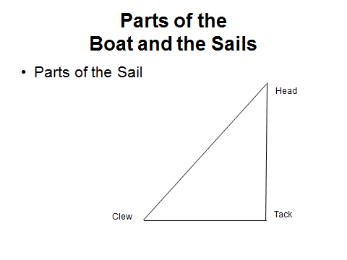

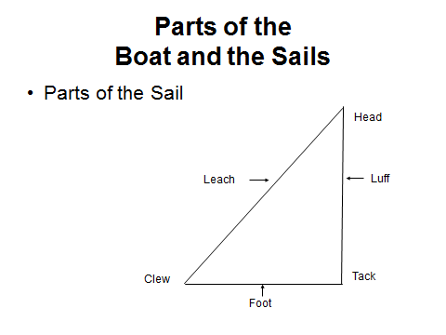

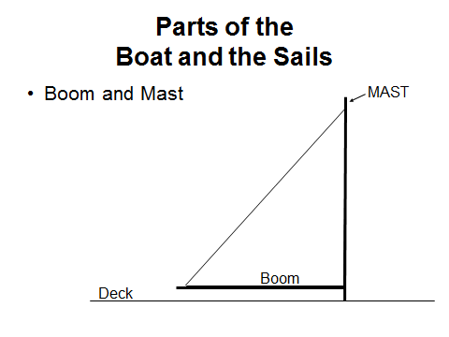

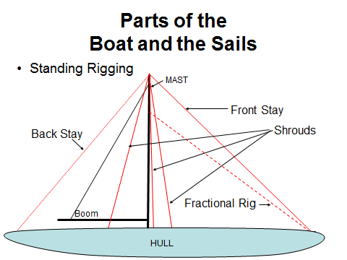
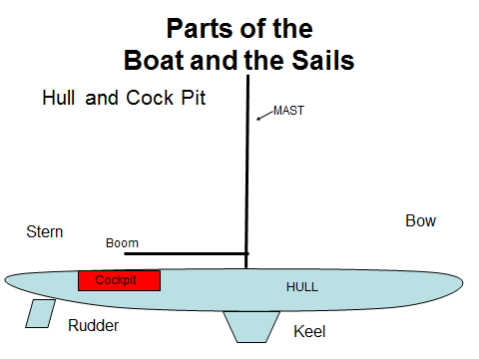

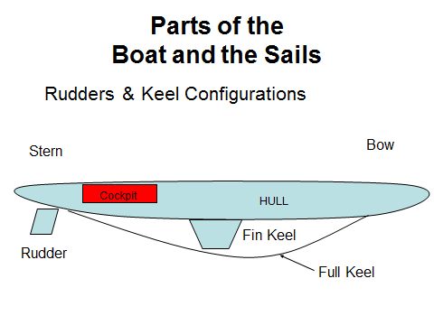
The Centerboard and/or keel
Not all small boats are exceptionally stable. Therefore, it is important to lower the center of gravity. This is done by lowering the centerboard. The centerboard allows the skipper to sail a course by preventing the boat from sliding across the water. With a small boat, whenever we leave the dock or return, the centerboard must be all the way down.

On larger boats, the keel serves a similar function as the centerboard. It lowers the center of gravity and helps the boat from sliding across the water but also offsets the forces associated with heeling so as to prevent the boat from being blown over or taking a knockdown.

Sail Terms and Measurements
http://shop.hunterowners.com/sails-doyle/rigterms.htm?fno=0

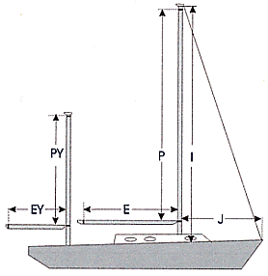

Courtesy of Doyle Sailmakers
Rig Terms
I | Deck to mast length - distance from the deck to the intersection of the forestay and and mast.
J | Forestay to mast length - distance from the forestay at the deck to the mast at the deck.
P | Main mast length - distance from the top of the main boom to the black band at the top of the main mast.
E | Main boom length - distance from the back side of the main mast to the black band at the end of the main boom.
PY | Mizzen mast length - distance from the top of the mizzen boom to the black band at the top of the mizzen mast.
EY | Mizzen boom length - distance from the back side of the mizzen mast to the black band at the end of the mizzen boom.

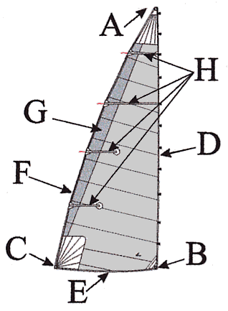
Sail Terms
A = Head, the top corner of a sail
B = Tack, the lower front corner of a sail
C = Clew, the lower aft corner of a sail
D = Luff, the forward edge of a sail
E = Foot, the bottom edge of a sail
F = Leech, the aft edge of a sail
G = Roach, the added material that sticks out beyond the theoretical "straightline leech," for better performance on all points of sail (shown as shaded area)
H = Battens, fiberglass slats or rods that hold the roach out and help to keep the leech of the sail flat

What (and what words) you should know before buying a sail
Buying a new sail can be a daunting task. There are so many sail lofts, styles, options, prices... and worst of all is the jargon! Some of these sailmakers forget we were all novices at one time...
What follows is an unbiased overview of some of the key terms and concepts you'll run across in your search.
Crosscut: A sail construction technique in which all the panels are parallel to each other and perpendicular to the sail's leech. Most Dacron cruising sails are crosscut.
Radial: A sail construction technique in which radial panels emanate from one, two, or all of the sail's corners (also called the head, clew, and tack). Radial designs are favored by racers for their additional strength.
Cunningham: A control that adjusts the position of the draft in a sail by changing the tension on the sail's luff. This control is a must for racing and used by some cruisers.
LP: The abbreviation for Luff Perpendicular, which designates the shortest distance from the clew to the luff of a Genoa. Genoa size is expressed in as a percentage, which is the LP divided by J. For example, if a boat's J measurement is 12 feet, a 150% genoa will have an LP of 18 feet. You may hear a sailmaker use this term.
Outhaul: The control line that pulls the mainsail clew to the end of the boom, tightening the foot of the sail and reducing draft. Chances are your boat is rigged for an outhaul; it's an important control.
Loose-Footed Sail: An option that allow you to add a substantial degree of extra fullness (referred to as depth and draft) in the lower portion of the mainsail in order to improve performance on reaches and runs. In very light air, the improved performance is achieved even to windward. The extra fullness is removed by tightening the outhaul. When the outhaul is eased, the sail maintains an airfoil shape down to the boom. A Loose-Footed sail is only attached to the boom at the tack and clew. This attachment method is equally as strong as that of the standard foot attached along the boom with slides or bolt rope. Many boats are switching to Loose-Footed mains due to the increased control of sail shape, plus they are easier to remove when necessary.
Telltales: Streamers attached to the sail to indicate wind flow. Don't buy a sail without these! The fundamental tool for sail trim.
Telltale Window: A small window for providing visability of leeward telltale.
Reefs: Mainsail reefs are used to depower a boat in strong winds. Reefing makes the mainsail smaller. Each row of reefs consists of a heavily reinforced patch with a grommet at the luff for the tack horn and a grommet at the leech for the reefing outhaul. Between the reefed tack and clew may be a row of evenly spaced smaller grommets (called reef diamonds) to provide a means of gathering up and tying off the excess sail. This row of holes is omitted in the case of a flattening reef because there is not enough excess material to worry about. The number of area-reducing reefs varies with the size and anticipated use of the sail. For boats over 26' two reef points is recommended. If you plan to do any offshore sailing or expect heavy weather three isn't a bad idea.
Battens: Battens are small, long rods that run through part of the sail parallel with the deck. They stiffen the sail and inhibit flogging. Full length battens run from leech to luff and provide even better shape holding ability, longer life and easier handling. They also induce a smooth airfoil shape to the sail, which improves performance in all conditions by holding up the leech. All major rating rules, IMS, MORC, and PHRF, permit sails with full-length battens with no change of rating. Most cruisers prefer two partial and two full battens. Full battens are installed at the top of the sail, partials toward the foot offering greater ability to adjust sail shape.
Sail Draft: The curvature or depth of the sail i.e the thickness of the airfoil (on the main this would be measured perpendicular to the boom). A deeper draft creates more power out of the sail.
Draft Stripe: A colored, horizontal stripe that helps you determine the draft depth in your sail.
Spreader Patch: Spreaders wear on headsails when you're close hauled. Spreader Patches should be used wherever spreaders can contact the sail.
Roach: The added material that stocks out beyond straightline leech, for more performance on all points of sail.
UV Cover: A Dacron fabric sewn to the leech of a furling Jib or Genoa to protect the sail from ultra-violet rays while furled. Often referred to as a sacrificial sun cover or shield.
Foam Luff: A foam luff provides better sail shape by flattening the head sail as it is furled. This means improved performance in reefed conditions.
Leech Line: Adjusts the tension along the leech of the sail to stop the leech from fluttering. Fluttering not only impedes performance, but also increases wear on the sail.
Rigging the Boat
The following Youtube videos show how to rig a Flying Scot -
- https://www.youtube.com/watch?v=vZ6O8lB0cII&width=640&height=480
- http://www.youtube.com/watch?v=-24efHbeL7U&width=640&height=480

The phrase “a picture is worth a thousand words” is very appropriate when trying to rig a sailboat the first time. It is nice to have two people rig the main while the third person rigs the jib sail. Rotate rigging positions each time you sail so you are comfortable with the two sails. Beginning with the mainsail, one student pulls the clew out to the
end of the boom while another feeds the foot down the boom. Once out, the tack pin is secured and the outhaul is tied and tensioned to current conditions. Another student can clear the luff edge and raise the sail about a foot up the mast. After the battens are inserted, the mainsail is finished. Do not raise the main until the boat is fully rigged and your plan for leaving the area is thought out. Before going up to the bow, release the jib halyard tension, attach the tack, luff edge to the forestay and finally, halyard to the head. Jib sheets are run inside the shrouds, through the fairleads and hexratchets
and are then secured with a figure 8 knot. Prior to raising the sails, lower the centerboard and check for all required safety equipment. The main is raised first, followed by the jib. This sequence helps hold the bow into the wind.

Maneuvers & Points of Sail

Getting Underway
Because a sailboat can not sail directly into the wind, the sailor needs to know all points of sail that a sailboat can sail. As we continue through the lesson, please take note of the wind diagrams provided.

When the wind is blowing over the bow, your boat is in “irons” or the no sail zone - the boat will not move, except drifting backwards. It is in this zone that you raise and lower your sails. Another term used when heading into the wind is luffing. Luffing is an excellent way to reduce speed to stop at a dock or mooring by using the sails as a brake.When you luff, the sails will flap noisily in the breeze just like a flag on a windy day. With the sails raised, you are now ready to fall off the wind (to move the bow away from the wind).

Once you have turned the bow so that the wind can blow on just one side of the sails, you are underway. Fall off typically about 45 degrees or more from where the wind is coming. Look at the wind diagram - in any of the sail zone areas shown other than the no sail zone, your boat will move.

As the boat turns away from the no sail zone, or falls off, the sails will fill with wind and you will sail away. Before you untie or cast off, check out the wind, other boats, and figure out a path that will let you leave without banging into anything.
- Wind
- Windward
- Leeward

The Points of Sail - https://www.youtube.com/watch?v=tYo5tvojU0I&width=640&height=480
As we already know, sailboats can sail 45 degrees (close hauled) on either side of the wind and any angle across (reaching) and down wind (running).
You will find that close hauled sailing is the most difficult point of sail to learn and for that reason, we start with this first.

- Close Hauled- approximately 45 degrees from the wind.
- Beam Reach- approximately 90 degrees across the wind.
- Running- approximately 180 degrees from the wind.
A second reason for knowing where the wind is from is that you can determine which lines need to be released in what order inorder to safely leave a slip.

Points of Sail Tacks Jibes and Irons

Tack – bow of boat goes through where the wind is coming from first and the boat is moving Through the “No-Sail-Zone”

- Tiller steering – push tiller towards sail to turn boat to and through where the wind is coming from;
- Wheel steering – Turn wheel away from the sail and towards the wind to turn the boat to and through the wind.
When tacking, be aware of thee wind conditions and the configuration of your boat. In a heavy wind a rapid movement of the tiller or wheel is necessary where in a light wind, you may need to back wind the jib to assist in getting the bow through the wind. Such a maneuver may also be necessary if your boat has a full keel.

Jibe – Stern of the boat goes through the wind first
- Tiller – moves away from the sail
- Wheel – turned in the direction of the sail, in the direction you want to go

Jibes and Jibing
- Jibing is a turn that needs to be planned in advance with the crew ready. Be aware that sailing dead downwind can be dangerous. If the wind changes direction, or the wake from a large powerboat running too close, or a large wave slues your boat around, the wind may get behind the mainsail.
- The sail will swing abruptly, and sometimes violently, to the other side. This is called an accidental jibe.

- A boom swinging at full speed can damage fittings and the boom itself, or even break a shroud and cause a dismasting. Furthermore, it can seriously injure you or a member of your crew.

- There are two ways to safely jibe. On a Flying Scot or any other small centerboard dinghy, you can safely do a “flying jibe”. The boom is let all the way out as you turn to a run. The skipper announces to the crew to “Standby to jibe”. When all of the crew replies they are ready, the skipper says loudly “jibe ho” and moves the tiller away from the mainsail.
- The jib sheet is released and the crew shifts to the other side ducking under the flying boom. The course is set and the sail adjusted till they are on the verge of luffing. Always remember that you do not have to jibe. You can always point up to close hauled, come about (tack) and then fall off to your desired course. When in doubt, come about!
- If you are sailing on our Hunter 42 or similar large boat, (basically any thing over 20 feet), however, the last thing in the world you would want to do is a flying jibe.

- On any larger vessel, you need to control the swing of the boom by executing a controlled jibe. As the boat turns on a run, the mainsheet is trimmed thereby centering the boom. The skipper gives the same commands and the boom jibes over and immediately the mainsheet is let out until the sail begins to luff. There is very little swing by the boom causing little wear and tear on the rigging. On a breezy day, the mainsheet has to be let out immediately.

Irons – brings the boat to a stop
- Bow is directly into the wind
- Sails are luffing on the center line of the boat

Summary of the points of sail
- Close hauled- 45 degrees to the wind allowing you to sail to an upwind destination. When the wind shifts direction, the skipper must shift the boats direction as well.
- Reaching - any point of sail between close hauled and the run. The skipper steers a course and the sails are let out until they luff and then trimmed till they stop. If the wind shifts, the sails shift, while the course remains steady.

- Running – also called wing on wing
The wind is directly behind –

Close Hauled sailing.

You are leaving the dock and decide you want to sail to Annapolis and the wind is coming from the north, the same direction from which the wind is blowing. How are we going to get there? We know that we can’t sail directly into the wind, and remember our
Instructor said something about sailing 45 degrees to the wind.
Assuming that we are on a starboard tack headed across the bay in a 10-15 mph breeze, the jib sheet is brought in fairly tightly on the port side and cleated off. The jib is our directional sail and the main provides the power. The main sheet is then trimmed in to get the boat moving. The goal of the skipper is to keep the boat at a constant 45 degree course to the wind. This is easy if the wind is steady. But as the wind shifts direction, our course must also shift comparably if we are to maintain the 45 line. The skipper steers the boat by watching the leading edge (luff) of the jib sail. If the course is too high, the sails start luffing and the boat slows down. If the skipper sails past 45 degrees, we end up sailing a longer course than necessary. Close hauled sailing is a balancing act. The boat pointed up till we begin to luff and then the boat is turned away from the wind until the sail fills once again.

As you can see, the jib sheet needs to be cleated so that the skipper knows that if the sail starts to luff, it is because the wind direction has changed and not that the crew has let out the sail accidentally. Sooner or later we will run out of water and have to turn the bow of the boat through the wind and onto a port tack. This process is called tacking or coming about. This is going to be a 90 degree turn if we are planning to sail close
hauled on the port tack.

The skipper does the following;
- Look for a landmark that is 90 degrees from the current close hauled heading.
- Announce to the crew to “Prepare to come about or tack”
- When the crew is ready, give the command “tiller to the sail” and turn the bow through the wind until the boat is on course to the new landmark.
The crew does the following;
- Let the skipper know you are ready.
- Uncleat the jib sheet and hold it.
- As the bow turns into the wind, release the sheet, and
- pull in the other sheet once the jib sail passes past the mast.
- Cleat the jib sheet as you move to the windward side of the boat.

Close hauled sailing is fun and exciting. The boat heels more at this angle than at any other. On a breezy day one of the crew should be responsible for handling the main sheet. There needs to be communication between the skipper and crew as to easing the main. The Scot tends to turn up into the wind on a gust (called weather helm) so the power of the main must be weakened by easing out on the main until the gust goes by.

Summary: When sailing close hauled, the boat is kept at a 45 degree angle to the wind. If the wind shifts, the skipper must shift the course as well.
The speed of the turn depends on the strength of the wind and the ability of the crew. In light breezes the turn is slow and smooth thereby preserving the boats momentum. In stronger breezes the turn should be done quickly so the sails can fill and get the boat going.

- Explain and identify using diagrams the following maneuvers, points of sail, and other terms:
No-Sail Zone | Closed Hauled | Sailing-by-the-Lee
In Irons | Close Reach | Stand-on
Luffing | Beam Reach | Give-way
Head-to-Wind | Broad Reach | Tacking
Port Tack | Run | Jibing
Starboard Tack
- Explain and utilize correctly the following helm commands and crew responses:
- ‘Heading Up’
- ‘Bearing Away’
- ‘Ready About’ ----- ‘Ready’ ----- ‘Helms a-Lee’ (or ‘Coming About’ or ‘Tacking’)
- ‘Prepare to Jibe’ ----- ‘Ready’ ----- ‘Jibe-Ho’ (or ‘Jibing’)

Session II (Review upwind sailing and focus on the reaches, runs & jibing)
Prior to going down to the boats, feel free to ask your Instructor to go over any of the pages on the flip charts that need clarification. You should be able to rig the Scot without the Instructor. There is only one way the parts fit so work as a team.

The second class concentrates on the reaches, run and downwind turns.

Sailing on a reach is easy. Simply put, aim at a landmark off the wind- let both sails out until they luff and then trim in to stop the luff and keep the boat flat.

Assume you wish to turn from a close hauled course to a beam reach heading. Ask yourself, am I turning into the wind or away from the wind? If we are turning away from the wind, the tiller is moved away from the sails and the sails go away from the boat.
How far do we let the sails out? Answer - till they luff.

Assume now that you would like to sail from a broad reach heading to a close reach. Again the same question. Are we turning into the wind or away from the wind? In this case we are turning into the wind. On a boat that uses a tiller to steer, The tiller is moved into the sails, the boat turns into the wind and the sails come into the boat until they stop luffing. On a boat that uses a wheel to turn the vessel, the wheel is turned in the direction you wish to go, so turn into the wind the wheel is TURNED AWAY from the sail.
- In general, the closer you sail to the wind, the closer the sails are pulled
- or trimmed to the midline of the boat. As you sail away from the wind, the sails
- are progressively eased out.
Always remember to change sail trim as you change course, according to this rule: First trim the jib, then trim the main.

As you can see from the diagram above, we can sail from a close hauled course to a run and vice versa, without changing the tack we are sailing on. When you sail your boat with the wind coming directly from behind, your jib will not fill if left to the leeward side behind the main sail. You can fill the sail with wind if you wing it out opposite the main. In the figure at the left, we have changed the direction of the wind to illustrate the downwind turn or the jibe. Jibing is a turn that needs to be planned in advance with the crew ready. Be aware that sailing dead downwind can be dangerous. If the wind changes direction, or the wake from a large powerboat running too close, or a large wave slues your boat around, the wind may get behind the mainsail. The sail will swing abruptly, and sometimes violently, to the other side. This is called an accidental jibe. A boom swinging at full speed can damage fittings and the boom itself, or even break a shroud and cause a dismasting. Furthermore, it can seriously injure you or a member of your crew.

There are two ways to safely jibe. On a Flying Scot or another centerboard dinghy, you can safely do a “flying jibe”. The boom is let all the way out as you turn to a run. The skipper announces to the crew to “Standby to jibe” .When the crew is ready, the skipper says loudly “jibe ho” and moves the tiller away from the mainsail.

The jib sheet is released and the crew shifts to the other side ducking under the flying boom. The course is set and the sail adjusted till they are on the verge of luffing. Always remember that you do not have to jibe. You can always point up to close hauled, come about (tack) and then fall off to your desired course.When in doubt, come about!

If you are sailing on a boat with a keel, however, the last thing in the world you would want to do is a flying jibe. On any larger vessel, you need to control the swing of the boom by executing a controlled jibe. As the boat turns on a run, the mainsheet is trimmed thereby centering the boom. The skipper gives the same commands and the boom jibes over and immediately the mainsheet is let out until the sail begins to luff. There is very little swing by the boom causing little wear and tear on the rigging.

On a breezy day, the mainsheet has to be let out immediately.

Summary of the points of sail
- Close hauled- 45 degrees to the wind allowing you to sail to an upwind destination. When the wind shifts direction, the skipper must shift the boats direction as well.
- Reaching - any point of sail between close hauled and the run. The skipper steers a course and the sails are let out until they luff and then trimmed till they stop. If the wind shifts, the sails shift, while the course remains steady.
- Running -sailing with the wind coming over the stern of the boat. The sails are all the way out. The skipper must pay attention to his course to prevent an accidental jibe.

Session III Rules of the road, channel markers, man overboard drills.
Vessels that must stay in the channel to avoid running aground have right of way over vessels that do not. You will see commercial ships, barges and large yachts on the Potomac.

You must yield way to these vessels regardless of whether they are sail or power.

Right of way rules are used to prevent collisions at sea. For your purposes, there are only a few that you need to know. However, if you continue on to racing sailboats, the rule book becomes suggested daily reading. Opposite Tack - When boats are on opposite tacks, a port- tack boat shall keep clear of a starboard-tack boat.
Same tack - When boats are on the same tack, the windward boat shall keep clear of the leeward boat
Overtaking - A vessel overtaking another on the same tack shall keep clear of that vessel.
Avoiding collision - A skipper must try to avoid a collision at all cost.

Navigation Rules
- Apply Rule 5 (Look-out) from the publication Navigation Rules, International - Inland.
For items 7 through 13, describe and use diagrams to apply the Navigation Rules. Identify the “stand-on” and ‘give-way” vessel in each situation.
- Sailing vessels with the wind on different sides (starboard / port), Rule 12(a)(i)

Rule 12 - Sailing Vessels
(a) When two sailing vessels are approaching one another, so as to involve risk of collision, one of them shall keep out of the way of the other as follows:
(i) when each has the wind on a different side, the vessel which has the wind on the port side shall keep out of the way of the other;
- Sailing vessels with the wind on same side (leeward / windward),
Rule 12(a)(ii) when both have the wind on the same side, the vessel which is to windward shall keep out of the way of the vessel which is to leeward;
- Sailing vessel on port tack cannot determine windward sailing vessel’s tack,
Rule 12(a)(iii) if a vessel with the wind on the port side sees a vessel to windward and cannot determine with certainty whether the other vessel has the wind on the port or on the starboard side, she shall keep out of the way of the other.(b) For the purposes of this Rule the windward side shall be deemed to be the side opposite that on which the mainsail is carried or, in the case of a square-rigged vessel, the side opposite to that on which the largest fore-and-aft sail is carried.

Rule 13 - Overtaking
(a) Notwithstanding anything contained in the Rules 4-18, any vessel overtaking any other shall keep out of the way of the vessel being overtaken.
(b) A vessel shall be deemed to be overtaking when coming up with a another vessel from a direction more than 22.5 degrees abaft her beam, that is, in such a position with reference to the vessel she is overtaking, that at night she would be able to see only the sternlight of that vessel but neither of her sidelights.
(c) When a vessel is in any doubt as to whether she is overtaking another, she shall assume that this is the case and act accordingly.
(d) Any subsequent alteration of the bearing between the two vessels shall not make the overtaking vessel a crossing vessel within the meaning of these Rules or relieve her of the duty of keeping clear of the overtaken vessel until she is finally past and clear.
Power-driven vessels approaching each other head-on (Rule 14) Rule 14 - Head-on Situation
(a) [ Unless otherwise agreed ] when two power-driven vessels are meeting on reciprocal or nearly reciprocal courses so as to involve risk of collision each shall alter her course to starboard so that each shall pass on the port side of the other.
(b) Such a situation shall be deemed to exist when a vessel sees the other ahead or nearly ahead and by night she could see the masthead lights of the other in a line or nearly in a line and/or both sidelights and by day she observes the corresponding aspect of the other vessel.
(c) When a vessel is in any doubt as to whether such a situation exists she shall assume that it does exist and act accordingly.
International | Inland
 | (d) Notwithstanding Rule 14(a), a power-driven vessel operating on the Great Lakes, Western Rivers, or waters specified by the Secretary, and proceeding downbound with a following current shall have the right-of-way over an upbound vessel, shall propose the manner of passage, and shall initiate the maneuvering signals prescribed by Rule 34(a)(i), as appropriate.
Power-driven vessel with another power-driven vessel on starboard side (Rule 15)
Rule 15 - Crossing Situation
(a) When two power-driven vessels are crossing so as to involve risk of collision, the vessel which has the other on her own starboard side shall keep out of the way and shall, if the circumstances of the case admit, avoid crossing ahead of the other vessel.(If you have a boat on your right that is approaching you perpendicular to the direction you are going, you have to stay out of that boats way and avoid collision).

International | Inland
 | (b) Notwithstanding Rule 15(a), on the Great Lakes, Western Rivers, or water specified by the Secretary, a power-driven vessel crossing a river shall keep out of the way of a power-driven vessel ascending or descending the river.

Appropriate actions to be taken when sailing in the vicinity of commercial traffic, including responding to a danger signal.

Aids to Navigation
- Aids to navigation by color, shape & numbering, including preferred channel markers. (Red “Nun” buoys, even numbered, pointed); Green “Can”, odd numbered, flat)
- Identify safe water, information and regulatory markers.(White can buoys with orange lettering)

Channel Markers are maintained by the United States Coast Guard to aid vessels restricted to deep water. Remember that if a large ship uses these markers, they do not get too close to any marker, nor should we as this is where shoaling can occur.
The basic rule to remember is Red-Right-Returning. Think of the red markers as indicating the right edge of deep water. If you were to draw an imaginary line between two red markers, it would be similar to the right edge of a road in driving a car.
Therefore, we leave all red markers on our right side as we return to the
head of the body of water (in our case, White Marsh Creek).

Green makers indicate the left side of the channel.. As you return to the port, the numbers on the markers increase and vice-versa.
When you are heading down Bear Neck Creek to the Rhode River toward the Bay, Red-Left-Leaving.

When a person falls in the water. (PIW)

The man overboard drill is one of the most important procedures you will learn. By the way, the drill is
correctly named since according to the Coast Guard and U.S. Navy statistics, 94% of overboard situations occur with men. This exercise should be mastered by all students on the boat.

Lets start with some of the reasons why people fall off a boat.
- Alcohol
- Rough seas
- Accidental jibes
- Children not safely secured to the boat.
- Unfamiliar boat

The drill is not hard to execute and applies most of the points of sail you have already learned. If you go sailing with friends after the course, explain before you leave the dock what will be done if someone should fall in. Fortunately, it is usually a hat or cup that falls overboard, but the drill is the same. Illustrated here is the quick stop MOB drill for keelboats. If some one falls in the water, here is what you do.
- Remain calm. It won’t do anybody any good if you panic.
- Throw the person a cushion or a life ring.
- Assign a crew member to continually watch the person.
- Sail a beam reach course 2-3 boat lengths away from the person
- Jibe the boat and return downwind of the person while on a beam reach.
- Release the jib sheet and use the sail as a wind indicator. When the
luffing jib point towards the person, make a sharp turn directly into the wind and come to a stop along side the person.

The drill is not hard to execute and applies most of the points of sail you have already learned. If you go sailing with friends after the course, explain before you leave the dock what will be done if someone should fall in. Fortunately, it is usually a hat or cup that falls overboard, but the drill is the same. Illustrated here is the quick stop MOB drill for keelboats.

Session IV (Docking & mooring practice,
general review)
The man overboard drill leads nicely into dockings and
mooring. We approach a mooring or dock in the same manner, from a down wind position. You will probably spend more time approaching moorings since our dock is often crowded. The key to successfully docking is to always have a back up plan if things aren’t happening as you had hoped. There is never an excuse for
crashing into the dock.
16
There are two ways to dock your boat, windward side and leeward side. Most common s the leeward side approach. You have to know the momentum your boat will carry so you can judge how far to be downwind before you turn into the wind and approach the dock.
Ideally the boat comes to a stop one foot from the dock or mooring ball. If you need to dock on the windward side of a dock, you can only do this with your sail down. Sail to a point directly upwind of your dock and turn into irons. Drop your mainsail completely and backwind your jib to turn the bow towards the dock. Finally drop you jib and allow the wind to push the boat gently to the dock.

Checklist for the docking
- Will this be a windward or leeward docking? All moorings are leeward.
- Is your centerboard all the way down?
- Is someone ready to attach the bow line to the mooring or to the dock?
- Is the wind steady or gusty?
- Are the sails uncleated as you begin your turn?
- Do you have a backup plan ready if you are coming in too fast or too slowly

Knots that every sailor should know
There are several knots commonly used in sailing. You won't use every one each day however, they all serve a purpose and each one will prove invaluable at some point in a week long voyage. Most of these are quite easy to tie and with a bit of practice you'll be amazed at your new found skills in rope tying. The knots are listed in their approximate order of usefulness.
- Bowline – The bowline almost defines sailing because of its versatility, usefulness, and strength. Since it's a popular knot there are many ways to tie it but you only need to know one.
- Figure 8 – This is the knot to tie in the end of a sheet or other line as a stopper. This
- prevents the line from running out through a block or line locker and escaping from you.
- Cleat Hitch. this knot has one and only purpose but that is a mighty one; Securing a
line to a cleat. Usually best to wrap at further end of cleat first then finish knot with
bitter end on your side of the cleat.

What’s the next step?
Becoming a proficient sailor takes time. You need to start experiencing as many different sailing conditions and types of boats as possible. Start your practice when the wind is less than 12 mph.
When in doubt, don’t go out. There is no reason to shake up your confidence by going out on a gusty day too soon. Sailing should be a lifetime sport. As your abilities and confidence improve, you might want to transfer your skills to larger cruising boats.
The larger the boat, the easier they are to sail!
PRACTICE AND HAVE FUN!

Safety Gear & Procedures
- Federally required equipment for a recreational sailboat of 25-feet in length.
Location and color of navigation lights used by a recreational vessel of 25-feet in length.
- Describe the purpose of a Float Plan, give examples of information contained therein and to whom it should be submitted.
- Describe when and to whom boating accidents must be reported.
- State the Federal Blood Alcohol Content (BAC) limit for vessel operation.

SKILLS
Safety Equipment
- Proper use of a lifejacket or personal flotation device (PFD).

Sailing
Rig/hoist/set sails safely and correctly to obtain proper sail trim using the following lines and controls, if available on the practice vessel
- Halyards and/or furling devices
- Downhaul or Cunningham
- Outhaul
- Boom Vang
- Mainsheet
- Jibsheets
- Winches
- Traveler
- Lower/furl/stow sails and coil/flake/stow lines properly

Without coaching or assistance from the instructor, verbalize appropriate commands and demonstrate competence, safety and good seamanship in the role of Skipper / Helmsman during the maneuvers listed in items 37 - 46. Honor all aids to navigation and use properly the basic Navigation Rules. Ensure sails are trimmed correctly and the vessel is in control at all times.
- Depart dock or mooring fully ready to get underway safely
- Select and maintain a given tack and course
- Demonstrate how to get out of “irons”
- Head Up
- Bear Away
- Sail Close Hauled
- Sail on a Close Reach
- Sail on a Beam Reach
- Sail on a Broad Reach
- Sail on a Run
- Tack
- Jibe
- As crew, give appropriate verbal responses and perform correct actions during the maneuvers listed above.

Crew Overboard
- Describe and demonstrate the correct actions to be taken while under sail from the time a person falls overboard until safely recovered.

Return & Secure
- Return to dock or mooring
- Secure vessel, using appropriate mooring/dock lines, fenders, etc.

TRAVELER PLACEMENT

Point higher, that is closer to the no sail zone, by using the traveler
1- do not bring the boom to windward past the center line. At center is fine.
It is all about BOOM location not the traveler. When beating or going to windward, close to the no-sail-zone, the traveler is almost always to weather.

The boom vang and mainsheet are used to set the correct twist in the sail, then the traveler is hauled to weather to center the boom.

The more twist there is in the sail, the further to weather or centerline of the boat, the traveler is moved.
Must understand:
- draft depth,
- draft position,
- twist and
- ANGLE OF ATTACK OF THE MAINSAIL TO THE WIND.

What sail trim controls on the main and jib are used to adjust those 4 elements. every sail trim control for the main and jib has a specific purpose. They are adjusting either draft depth, draft position, twist or angle of attack
The traveler adjusts - It adjust ONLY the ANGLE OF ATTACK
Pull or haul in on the traveler and move the boom toward the centerline and the boat speeds up. Ease the traveler so the boom moves away from the centerline and the boat slows down.

The traveler works relative to sail shape. The fact that the traveler does not change the shape of the sail is exactly why it is used to bring the boat back on its feet when it is heeled over too much.

Changing Sail Shape and Angle of Attack to the Wind
6 lines that can be pulled on to change either the shape of the mainsail or how it "attacks" the wind.

- The Halyard flattens (reduces draft depth) the forward portion of the sail and moves the deepest draft forward
- The Cunningham does the same but mainly for the bottom 1/3 of the mainsail
- The Outhaul flattens (reduces draft depth) the entire bottom half of the mainsail
- The leach line is pretty much worthless but can stop that annoying flutter in the leach once you get everything else trimmed up
- The traveler changes the sails angle of attack (just like the elevator on a plane) with the wind
- The main sheet or vang controls the draft depth and twist of the sail
Sail Shape:
- Extreme
- Everything in Between
Extreme:
The shape of the sail should be big and baggy for light winds and flat as a pancake for high winds. Consider how an airplane wing is shaped for a particular type of aircraft. A plane such as a transport is big slow and has very big wings with a lot of curve (draft) to them. They need all that wing area to make lift at the low air speed at which they fly. A smaller faster fighter jet has small flat wings because they use their higher air/wind speed to produce the lift they need.

As applied to sailing and sail shape, for all lines except the traveler, sheet and boom vang, Loosen up the lines in light airs and tighten them up in higher winds. Set the traveler so that the mainsail luft is aligned with the windex. Set the sheet/vang for proper tale-tell streaming.

Also, when you reef (higher winds, smaller wings) you flatten the sail.
Trim the foresail first then the main as the foresail redirects the airflow.

